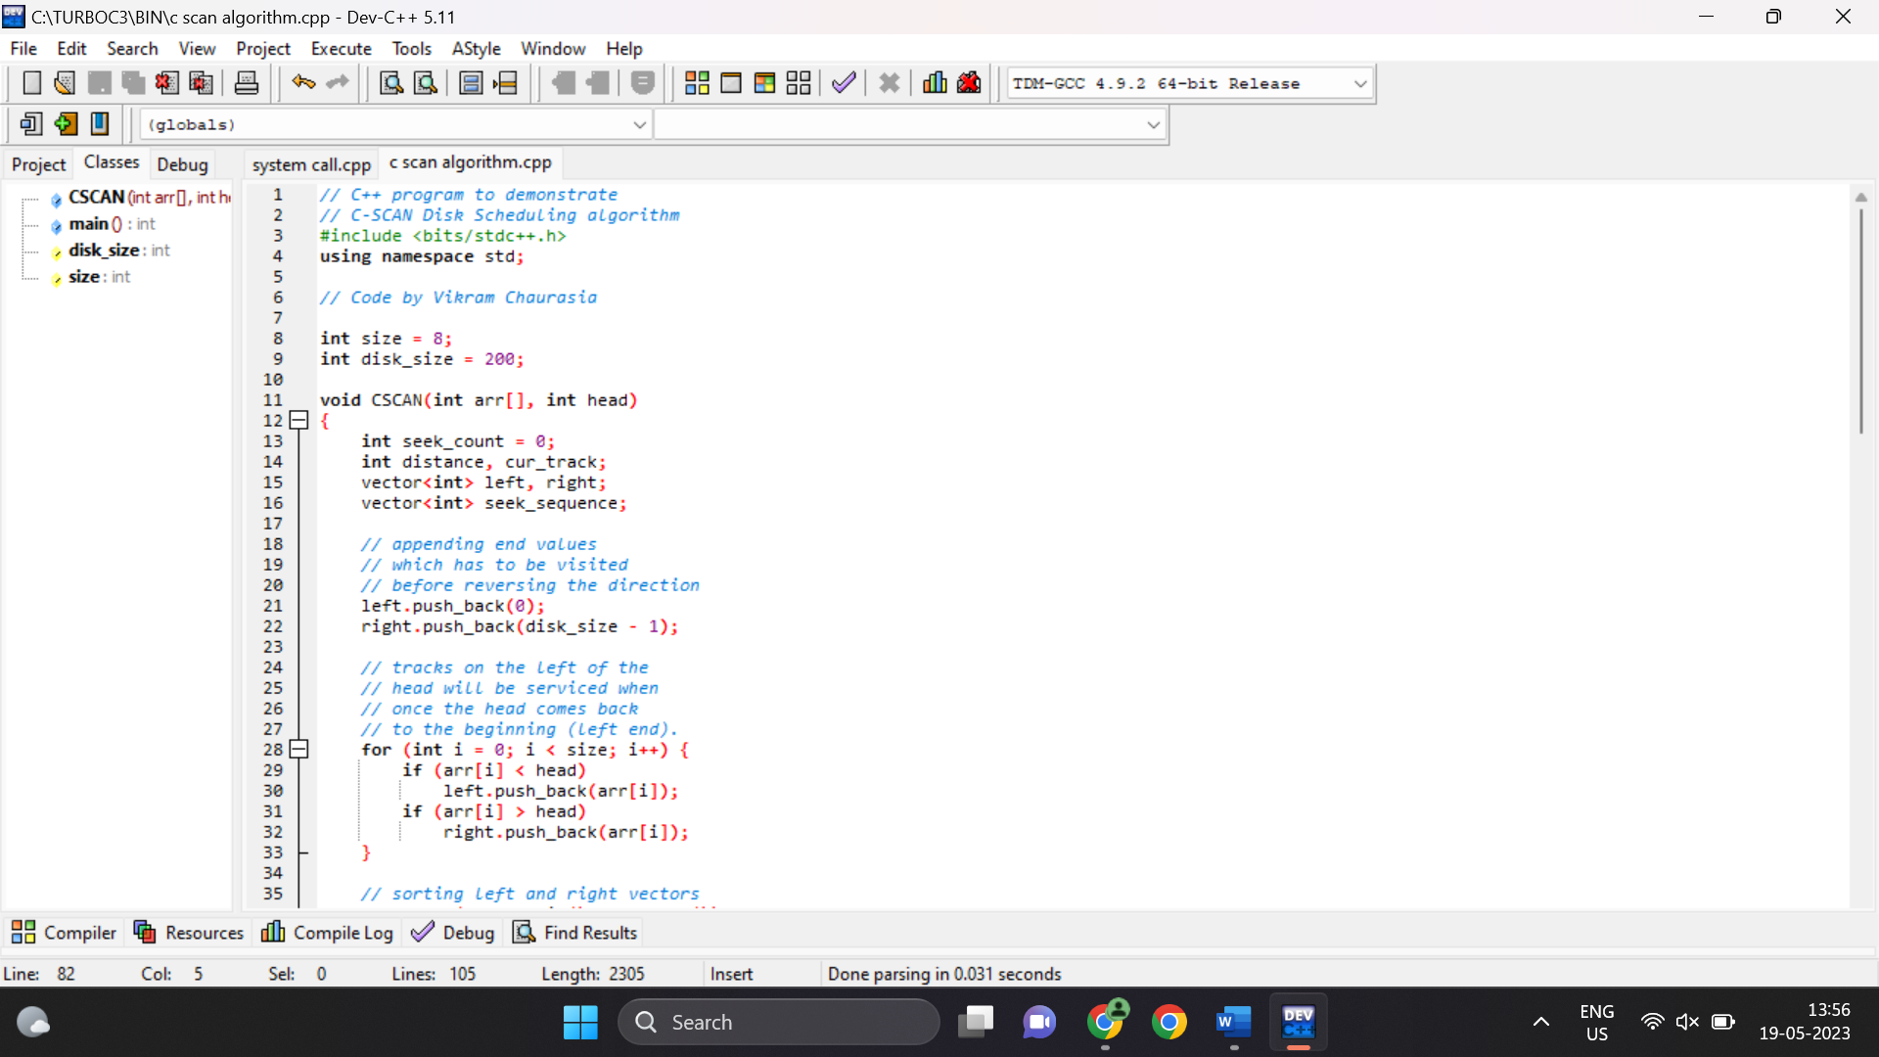

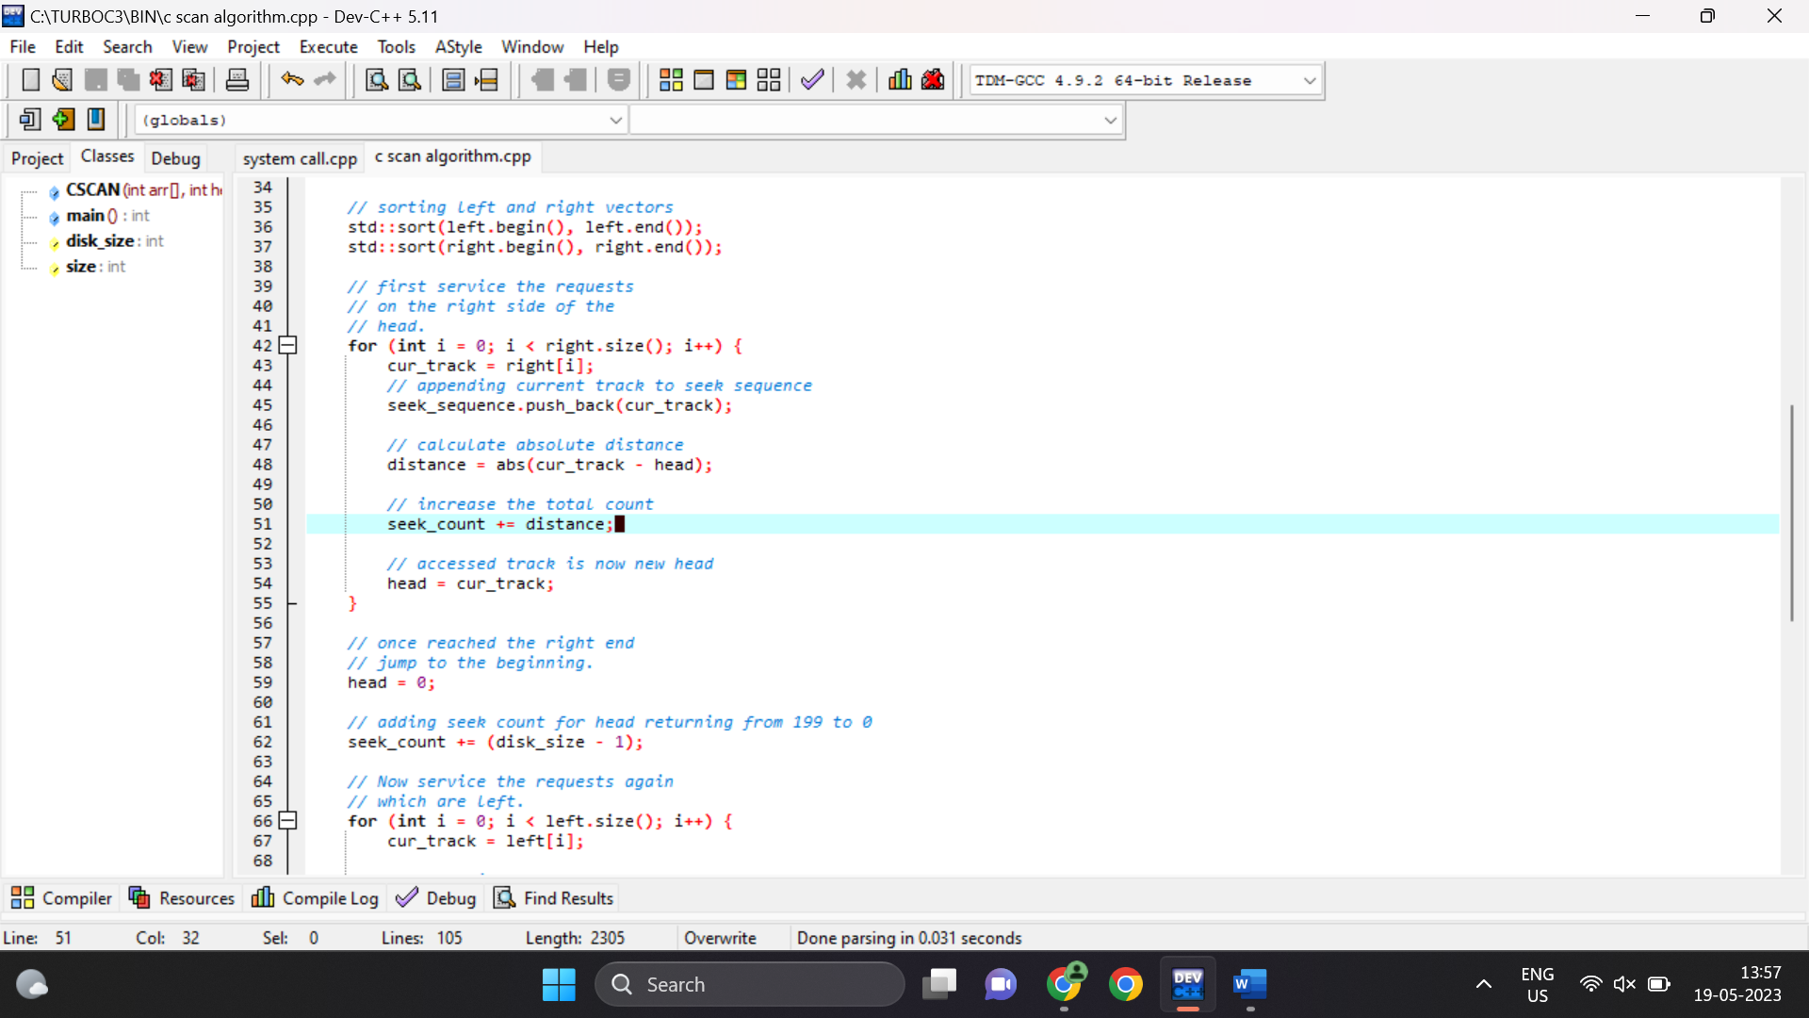

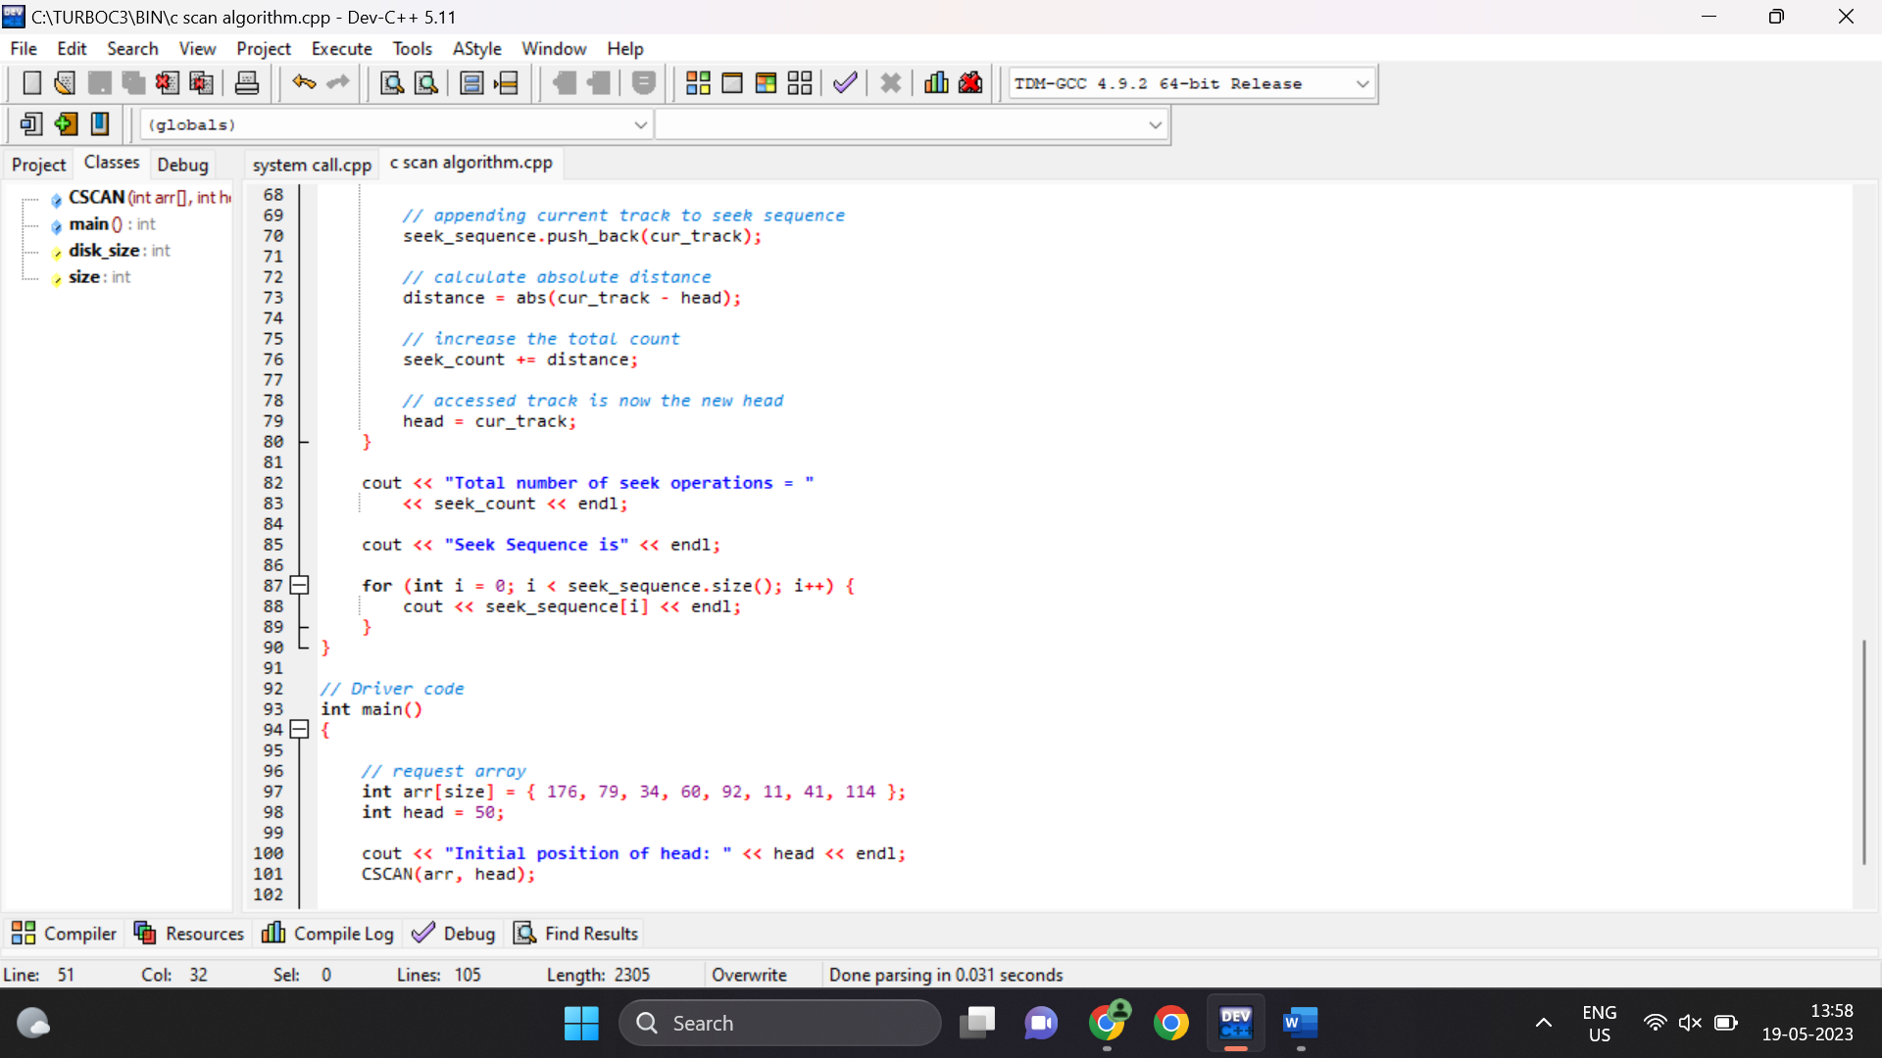

Output:

Initial position of head: 50

Total number of seek operations = 389

Seek Sequence is

60

79

92

114

176

199

0

11

34

41

--------------------------------

Process exited after 0.07577 seconds with return value 0

Press any key to continue . . .